AI Assisted Coding - Lab Test 4
ENROLLMENT NO:2503A51L15
NAME:MOHAMMAD KHAJA AFZALUDDIN
BATCH NO:19[SET-4]

Lab 4:
Q1. API Integration
a. Generate code to fetch flight details using a REST API.
PROMPT:-
Generate a simple example code snippet that fetches flight details from a public REST API using any programming language. The API request should include parameters such as source, destination, and date. Also handle errors and print the response in a readable format.
CODE:-
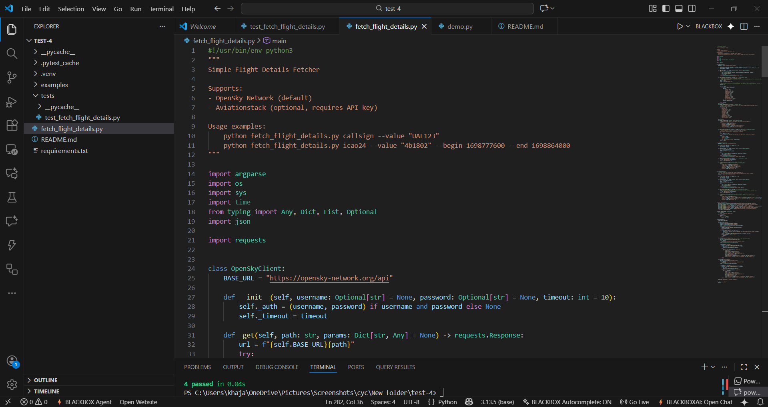
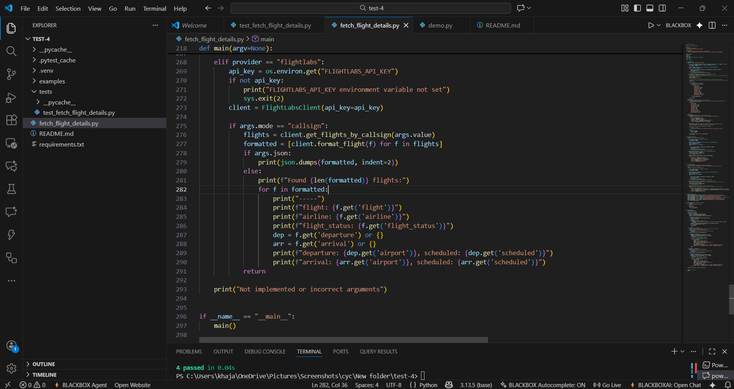

OUTPUT:-
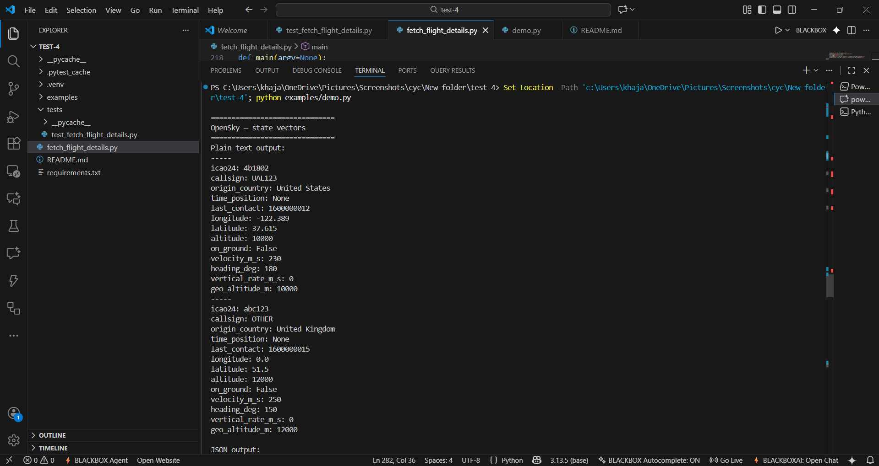
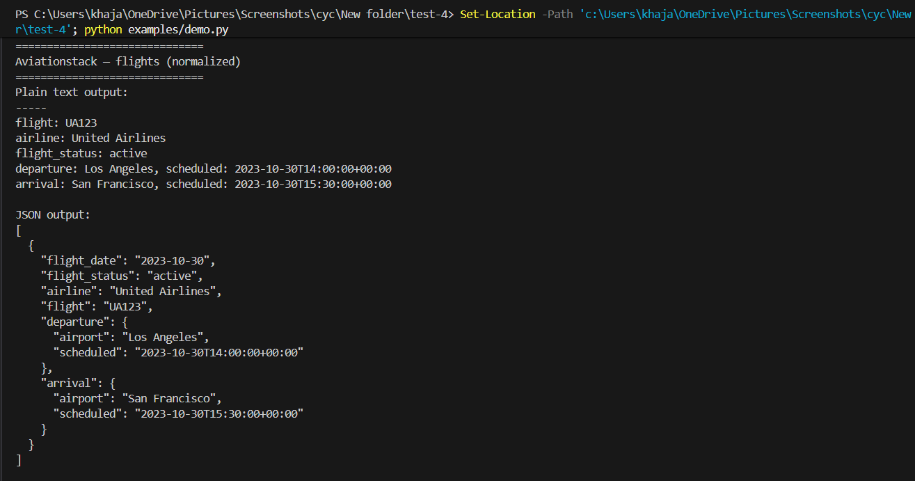

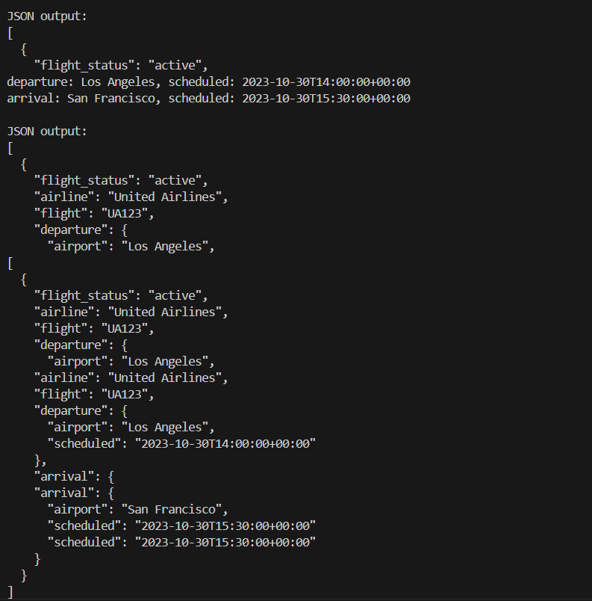

OBSERVATION:-
The task checks whether the model can correctly use HTTP request methods, include query parameters, handle response parsing, and manage error handling during API integration.

b. Add retry mechanisms for network failure using AI suggestions.

PROMPT:-
Improve the existing API call by adding a retry mechanism to handle network failures. Use AI-suggested logic such as exponential backoff or delayed retries. Keep the implementation simple, readable, and efficient.
CODE:-
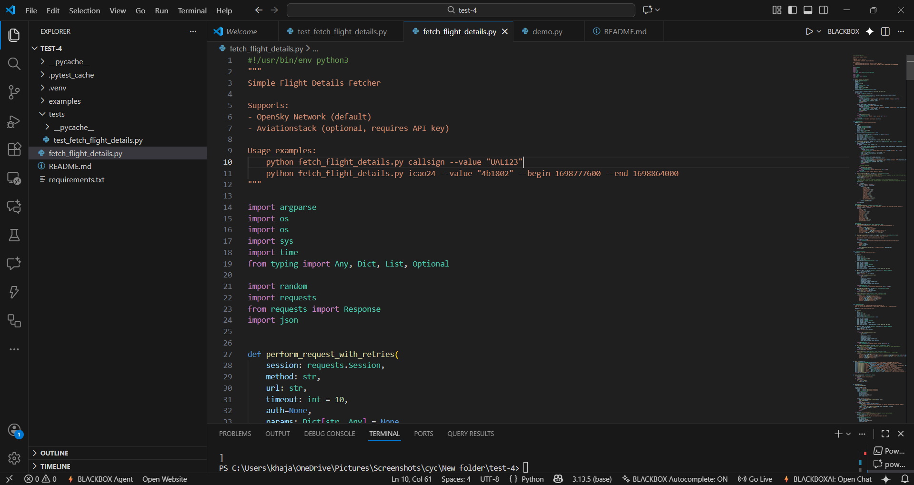

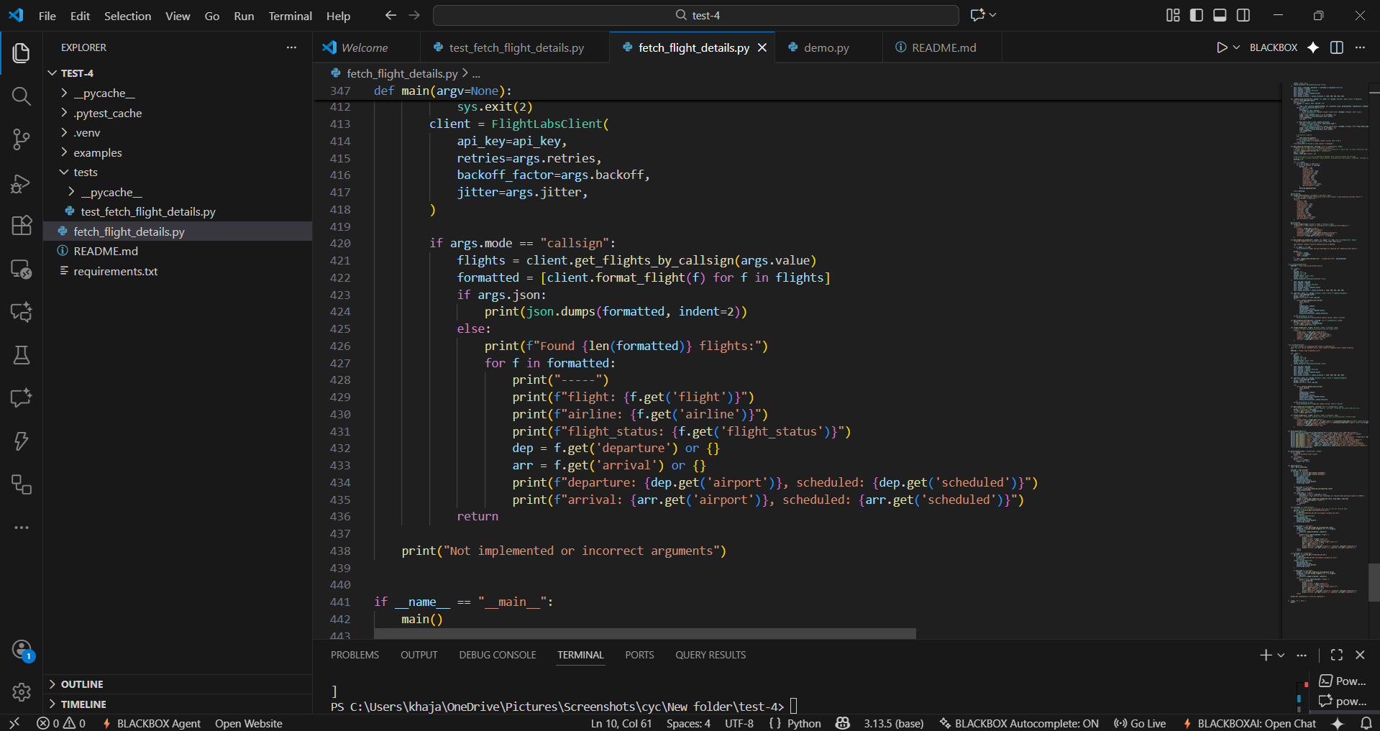

OUTPUT:-
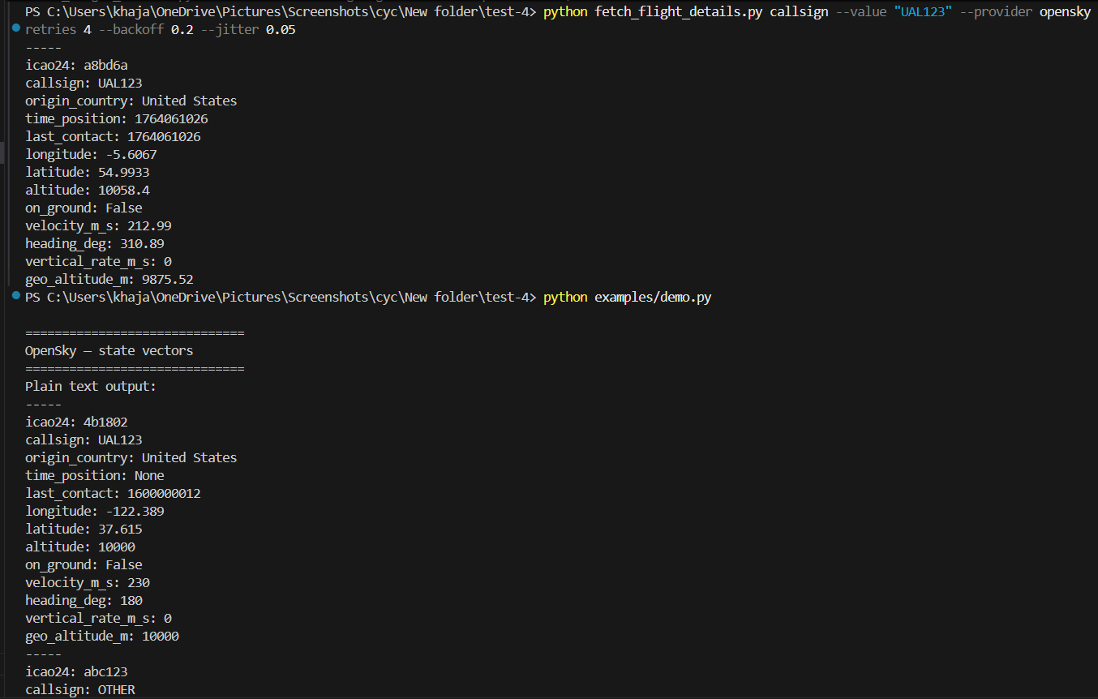
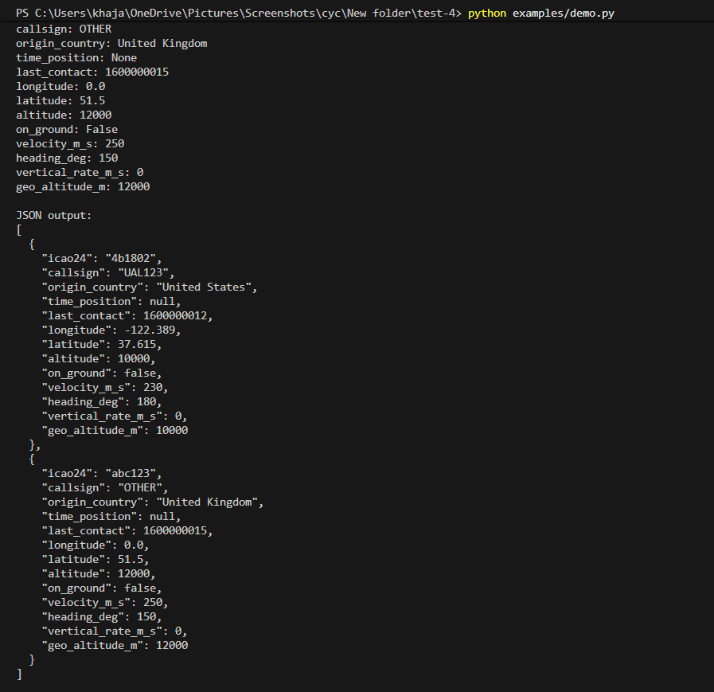
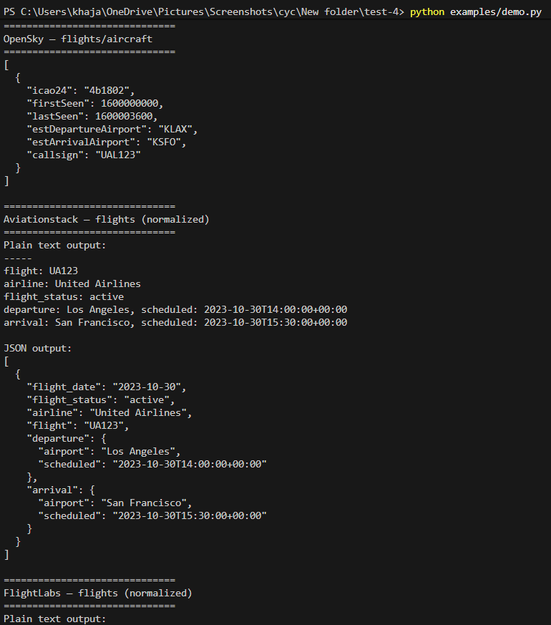
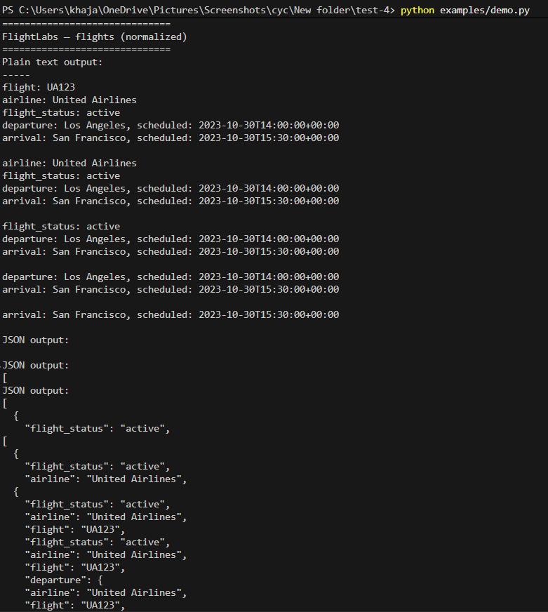
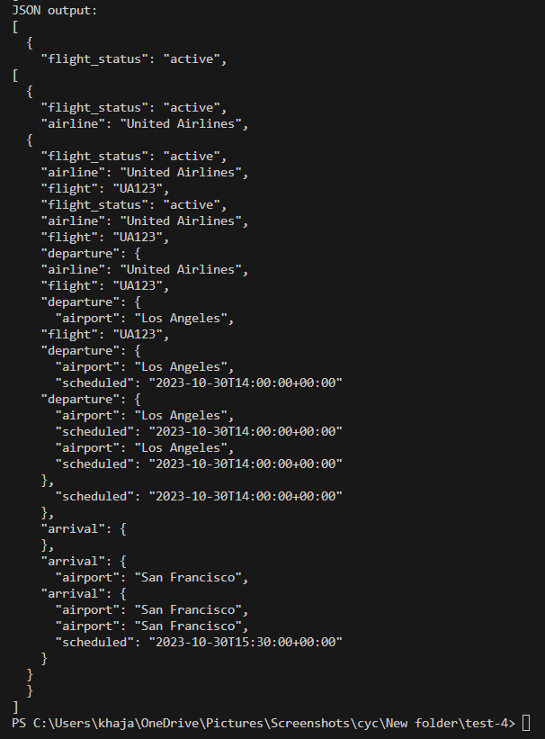
OBSERVATION:-
This task evaluates whether the retry logic is correctly implemented, avoids infinite loops, and gracefully handles repeated failures. It also checks if AI suggestions are applied logically and the code remains maintainable.
Security Testing
a. Ask AI to scan generated API code for security vulnerabilities

PROMPT:-
Review and scan the generated API integration code for any potential security vulnerabilities. Identify issues such as insecure API keys, missing input validation, improper error handling, exposure of sensitive data, or weak authentication. Suggest improvements to make the code more secure.

CODE:-
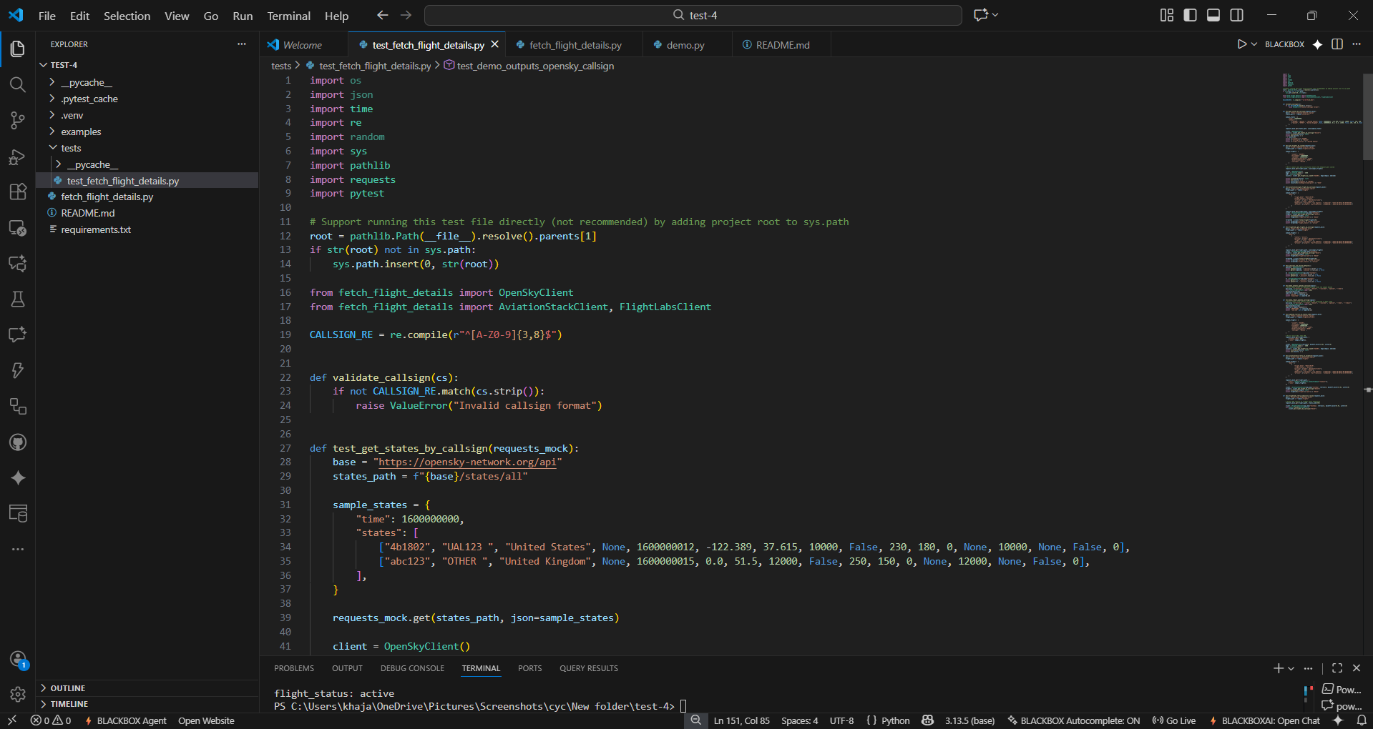
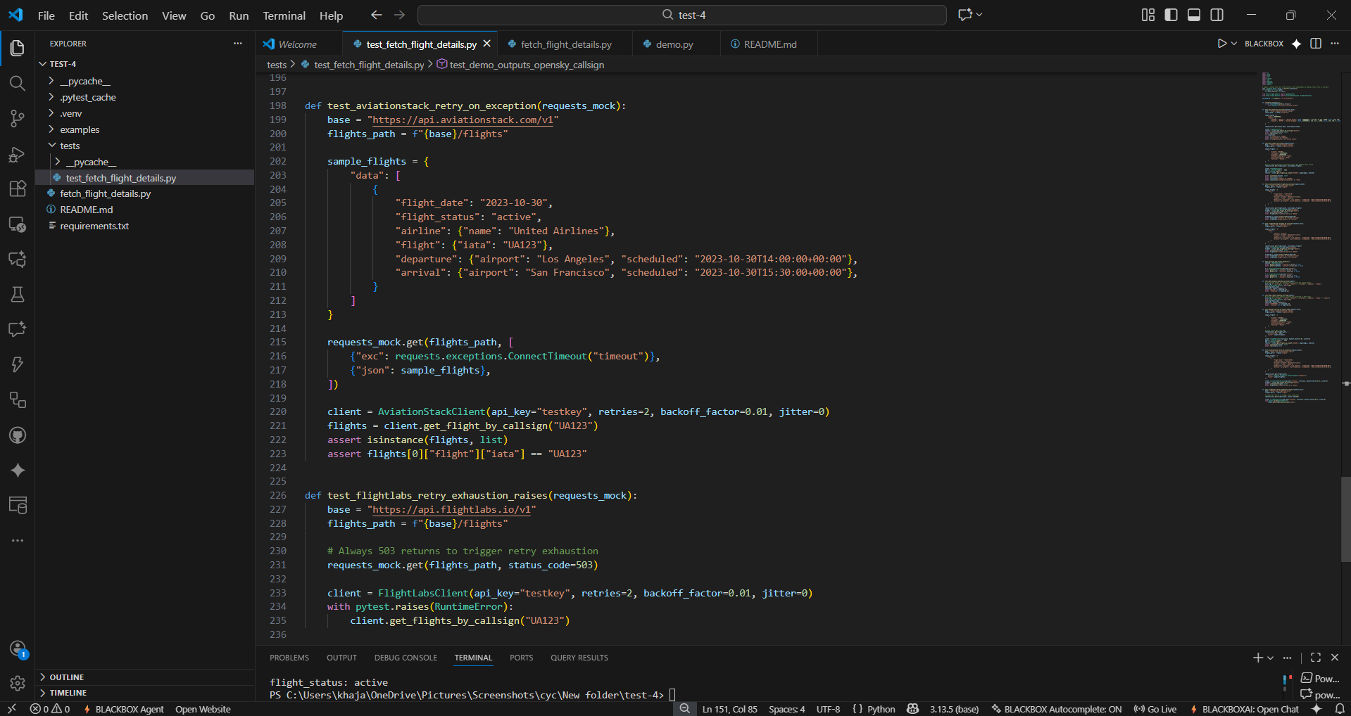

OUTPUT:-
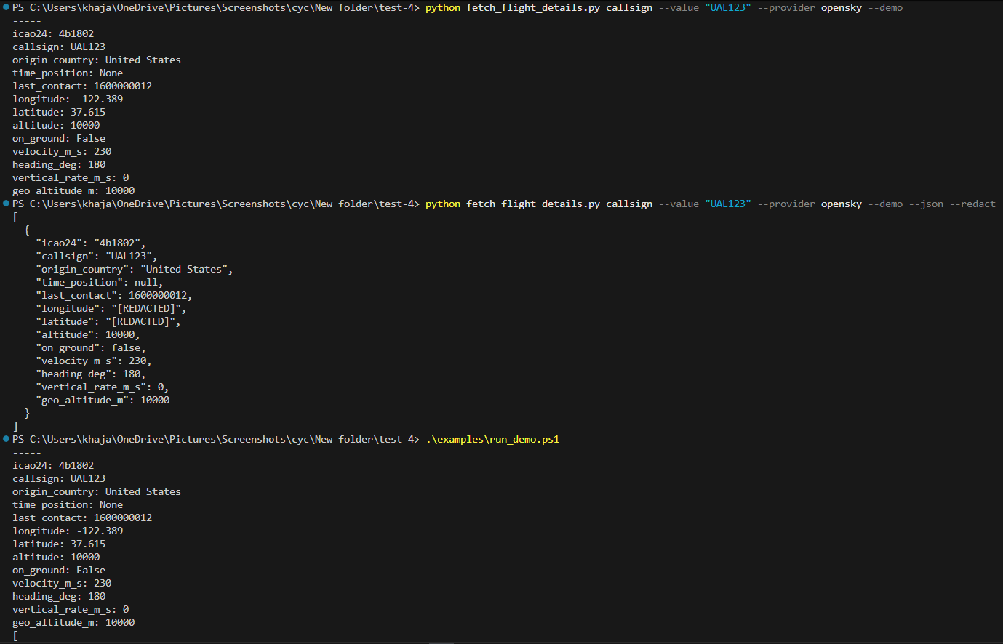
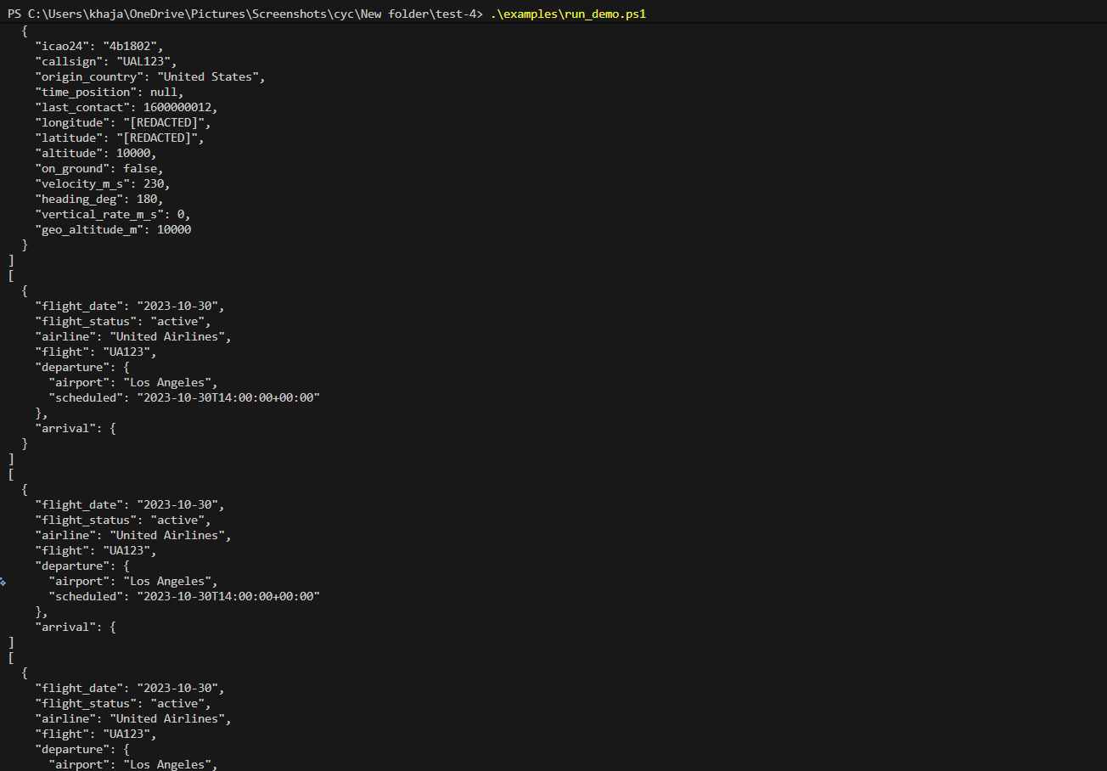

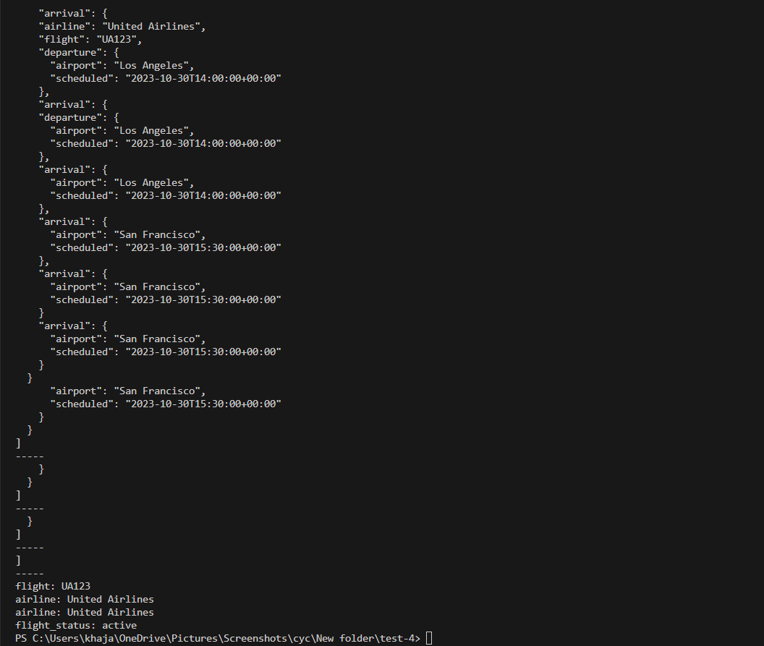

OBSERVATION:-
his task checks whether the AI can detect common security risks, recommend best practices, and ensure the API code follows secure programming standards without breaking functionality.

b. Fix vulnerabilities such as hard-coded API keys or unsafe error messages.

PROMPT:-
Generate the code to Fix vulnerabilities like hard-coded API keys and unsafe error messages in the API code.

CODE:-
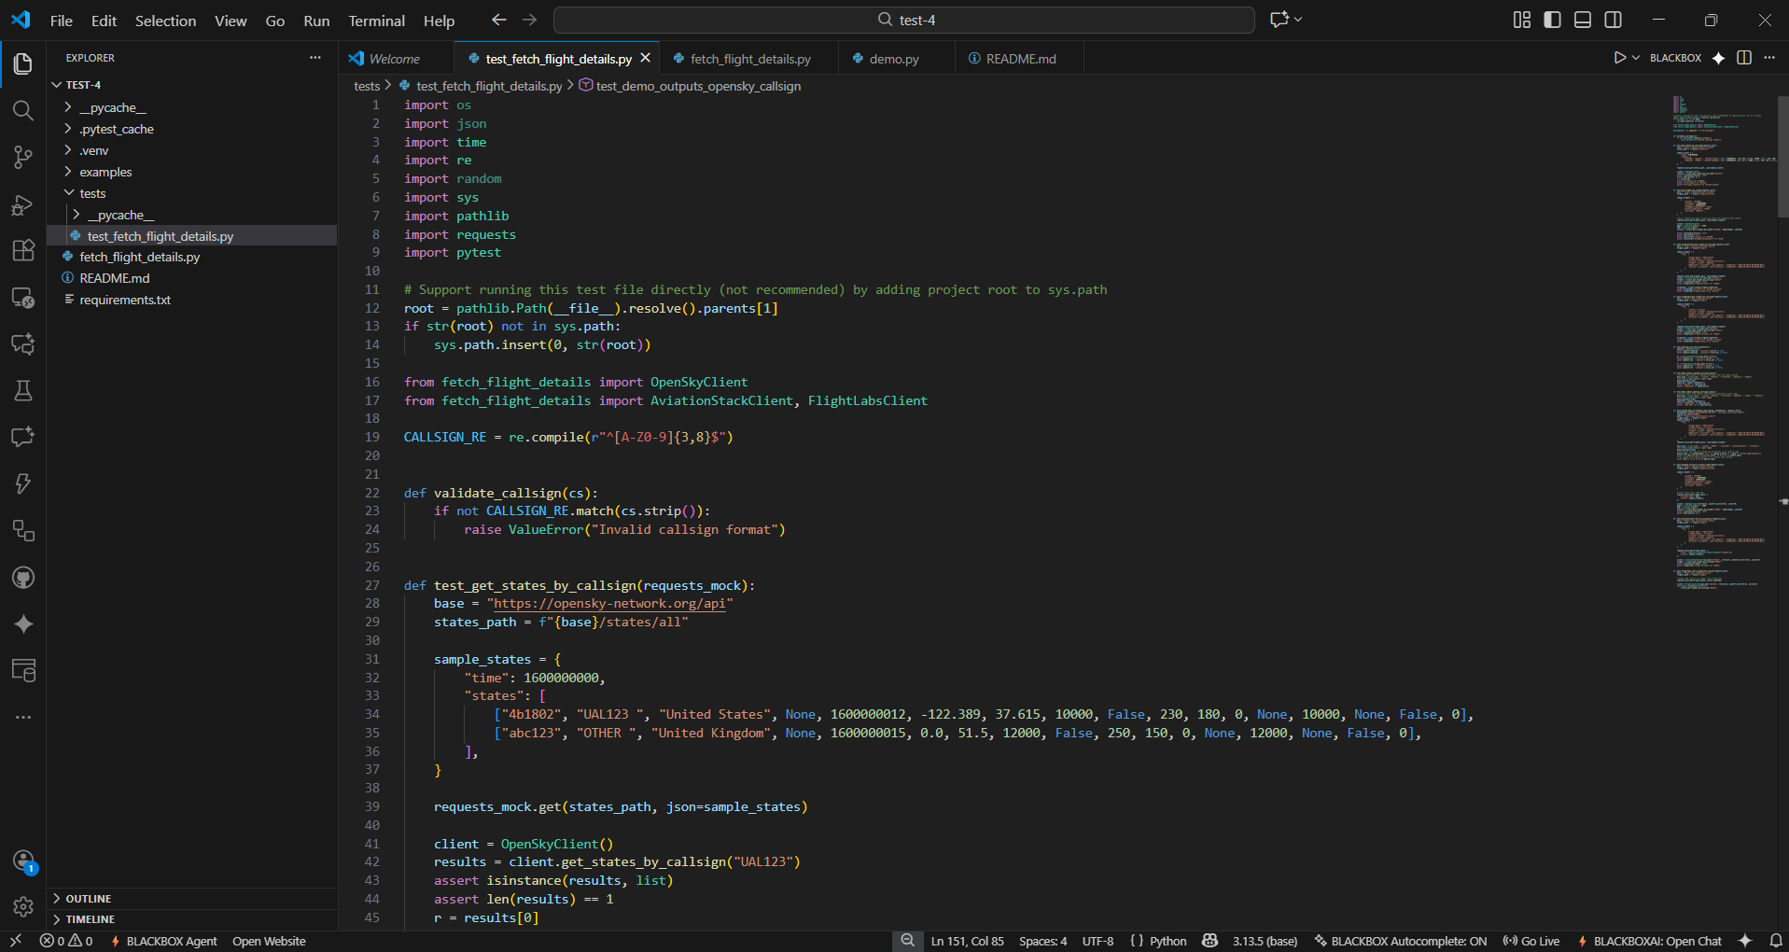
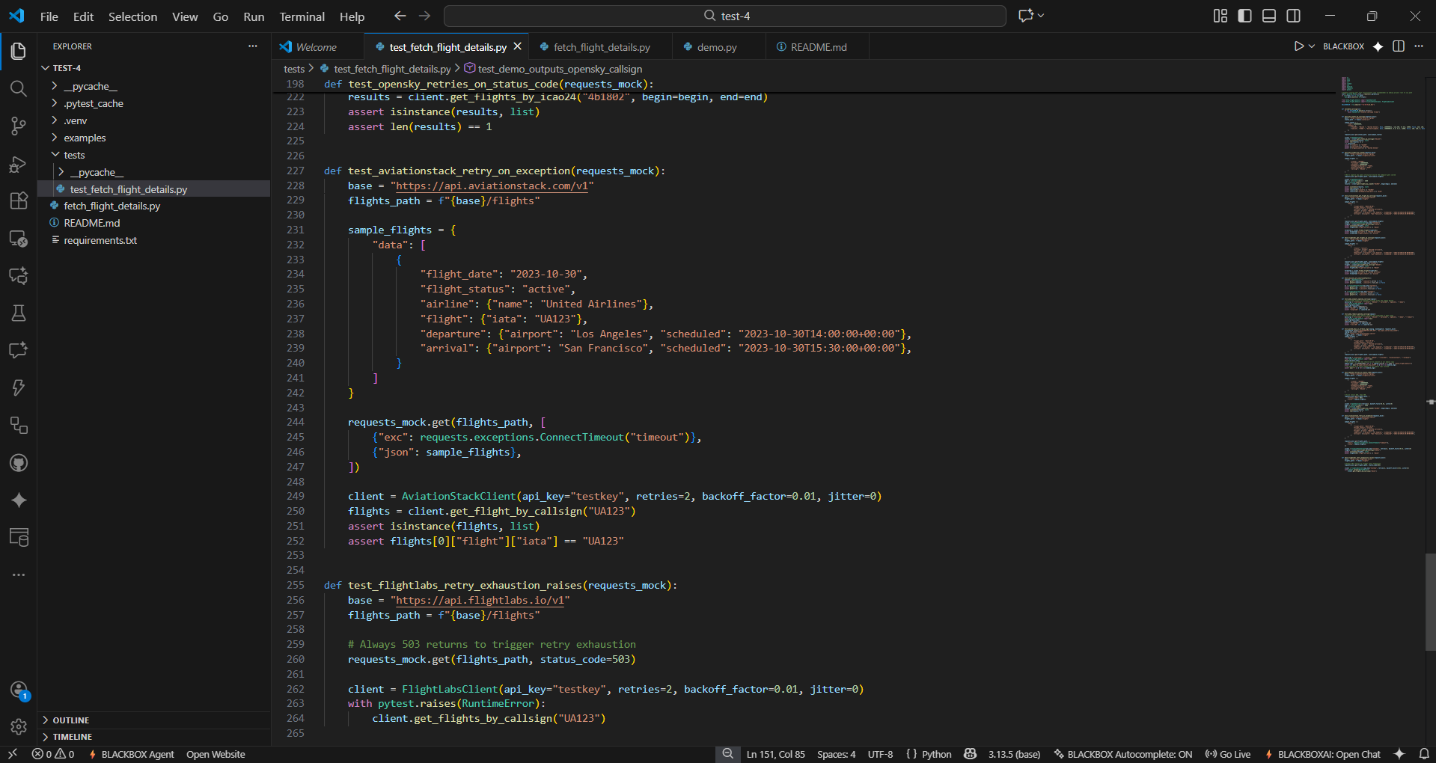

OUTPUT:-
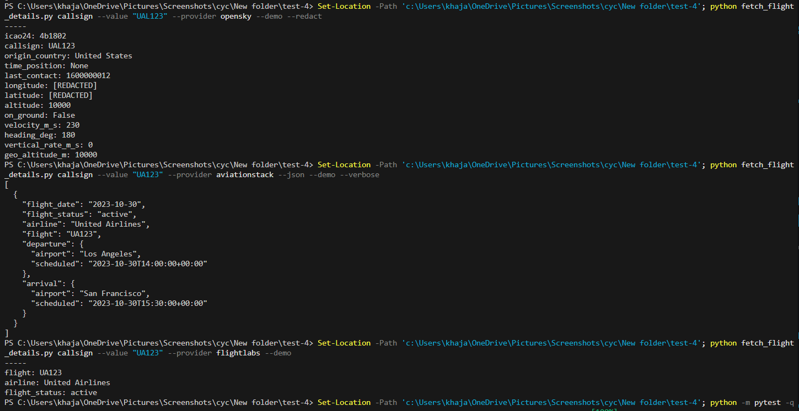

OBSERVATION:-
This task helps determine whether the AI can recognize insecure coding patterns and apply appropriate remediation steps. It evaluates the ability to replace exposed credentials with secure storage methods such as environment variables and ensure that error messages do not leak sensitive implementation details.

